EXP 1-2 Same or Different Report P2
Zeng Xinquan 2020304140 Yang Yu 2020304157 Sun Wenshao 2020304137
Zhang Chengyu 2020304104 Liu Zhening 2020304085 Li Yuntong 2020304106
Section 1: Identify and correct mistakes and errors in experiments and data processing.
The experimental mistake is generally caused by the wrong operation of the experimental process and data processing process, which should and can be corrected. Experimental error is the difference between the measured value and the real value, which is inevitable and unavoidable in the measurement process. To analyze the overall experimental data, identify the mistake data and error data, and modify the mistake data.
● Mistakes:
Type 1: Beyond the elastic deformation interval. ------------------ Relevant groups: M2, M6, P5.
Decision: Delete the last row of data in M2 and M6.
The last set of data of M2 and M6 has exceeded the elastic deformation interval, and the accuracy of the calculated modulus is affected. Therefore, the data beyond the elastic deformation interval should be deleted to ensure the calculation of the modulus.
Type 2: The abnormal stress and strain. -------------------------- Relevant groups: M35, P12, PB.
Decision: Delete abnormal data in M35 and P12, and change the strain to 0 in PB.
M35, the second group of data, the stress is small but the strain is large, the data is abnormal, delete. P12, the second group of data, without strain but with stress, abnormal, deleted. In PB, after the first application of stress, the strain becomes negative, which is abnormal. Change the strain to 0.
Type 3: The processing problem of experimental data.----------------------- Relevant group: P8.
Decision: Add up the weight and calculate the result again.
The experiment is to add continuous extra weight, record continuous weight, and finally distance. The stress and modulus calculated without cumulative weight are wrong. Weights need to be added up and recalculate the modulus.
Type 4: Typing mistake. ---------------------------------------------------------- Relevant groups: P2.
Decision: Correct the wrong number (25mm to 2.5mm).
The thickness of the sample reported by P2 is 25mm, but it should be lacking a dot.
Section 2: Data gotten are representative after correcting mistakes.
● Parameter 1: R²
The coefficient of determination (R²) is used to judge the fitting degree of the regression equation^{[1]}. For the data provided, most results provided by polymer and material have R² near 1, meaning the regression equation fits the data well. However, for P8 and M11, R² is particularly low due to a mistake. After correcting the mistakes, the R² value became a satisfying value. Besides, the R² of the M38 Group is lower than 0.9 due to the error.
● Parameter 2: Standard deviation (SD) and Standard Error (SE) of the experiment result.
SD reflects how discrete a data set is^{[2]}. The standard error of the mean indicates the degree to which the population means differs from the sample mean^{[2]}. In this experiment, the stand error shows how well the modulus is presented by the experiment result and helps to determine the significant figures. And stand deviation of each sample is used for further testing.
Section 3: Introduction
● Error analysis
The several errors that exist are listed as follows:
- Written error. The significant value of the result of measurement for each experiment is different, some groups keep the accuracy to 0.1 gram while others are not.
- Measurement error. This error may occur in the case of inappropriate experimental operation or insufficient accuracy of experimental instruments. P5, P12, P13, and M37 failed to record the change of strain while the stress is increased. This may be due to the insufficient accuracy of the instrument or uncareful reading.
- Recording error. Some data haven’t been recorded in the correct form compared with other groups. For example, P8 hasn’t accumulated the weight applied. And a row of data is missing in P22 and P24.
● Unit analysis
The unit of the calculation in the original table is Pa. It is not intuitive and can’t well represent the tested polymer. To study how many figures in the modulus obtained are capable to show the property of the polymer tested, the SE of each experiment is calculated and the confidence interval is determined by CI=1.96*SE for 95% confidence. Since the CI is calculated to be in kPa, using kPa as the unit can eliminate all zeros and keep all significant figures. The modified data can better represent the population and is easier for further calculation. The comparison between modified and unmodified data is shown below.
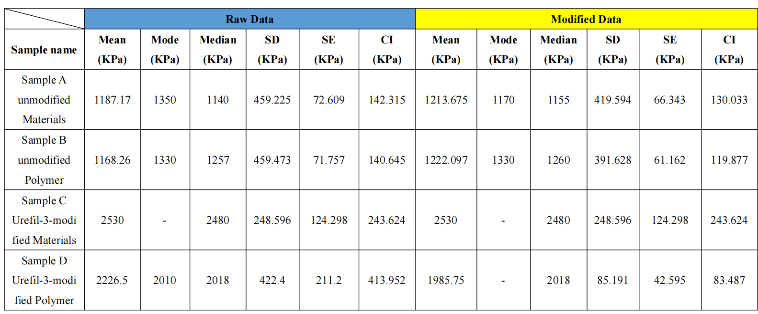

Table 1. The data before and after modification
Section 4: The normal distribution investigation
● Normality Test
To determine if the data samples follow a normal distribution, we can perform a normality test. One common test is the Shapiro-Wilk test^{[3]}. The null hypothesis for the test is that the data follows a normal distribution. If the p-value of the test is less than 0.05, we reject the null hypothesis and conclude that the data does not follow a normal distribution.
By using statistical software or a spreadsheet program like Origin, we can perform the Shapiro-Wilk test on each of the four groups of samples, the results of the normality test has been shown below:
Sample name | Sample size | Mean  (KPa) | Median  (KPa) | SD  (KPa) | Test method | Statistic value/p-value | Test result
Sample A  unmodified Materials | 40 | 1213.675 | 1155 | 419.594 | Shapiro-Wilk Test | 0.897  (0.002) | Reject the null hypothesis, not satisfy the normal distribution
Sample B  unmodified Polymer | 41 | 1222.098 | 1260 | 391.629 | Shapiro-Wilk Test | 0.978  (0.618) | Can’t reject the null hypothesis, satisfy the normal distribution
Sample C  Urefil-3-modified Materials | 4 | 2530 | 2480 | 248.596 | Shapiro-Wilk Test | 0.945  (0.685) | Can’t reject the null hypothesis, satisfy the normal distribution
Sample D  Urefil-3-modified Polymer | 4 | 1985.75 | 2018 | 85.191 | Shapiro-Wilk Test | 0.79  (0.086) | Can’t reject the null hypothesis, satisfy the normal distribution
Table. 2 Normality test results
Based on the Shapiro-Wilk test, at the significance level of 0.05, we can conclude that the data from Sample A-unmodified Material and Sample D-Urefil-3-modified Polymer does not follow a normal distribution, while the data from Sample B-unmodified Polymer, Sample C-Urefil-3-modified Material can be assumed to follow a normal distribution.
● Histogram Graph
To determine whether the data follow a normal distribution, histogram also can be created and visually inspect the distribution of the data. For the histogram (a) of the unmodified material in figure1, there still exists drift of mean value towards the left side in the normal distribution. In the histogram (b) for unmodified Polymer, the data are roughly normally distributed, with a bell-shaped curve in the histogram which is supported by the fact that the mean, median, and mode are all relatively close in value.
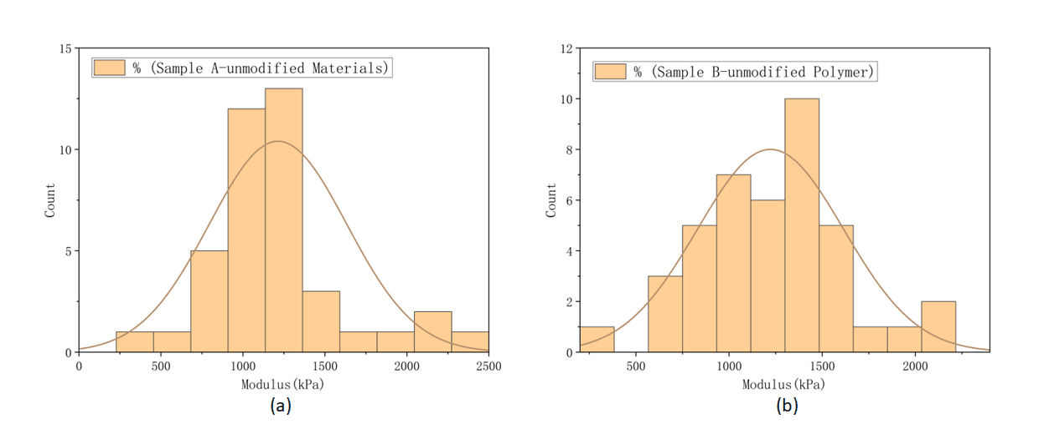
Figure 1. The histogram and normal distribution of (a) unmodified material sample and (b) unmodified polymer sample
Section 5: Comparability study of the data about unmodified sample provided by material group and polymer group
● Method 1: T-test
After correcting the mistakes, the sample size of both groups is larger than 30, thus the central limit theory holds true for both groups and the t-test is available since they’re regarded to be normally distributed. The two-tailed two-sample t-test is applied, and regarding two samples is of equal variances. The formula shown below is applied to obtain the t-value:
$$\begin{aligned}t=\frac{{\overline{X}}_{1}−{\overline{X}}_{2}}{\sqrt{\frac{{S_{1}}^{2}}{n_{1}}+\frac{{S_{2}}^{2}}{n_{2}}}}\#\left(1\right)\end{aligned}$$
As shown in table x, the t value is calculated to be 0.1886. The degree of the freedom is calculated by the formula (2):
$$\begin{aligned}v=n_{1}+n_{2}−2=78\#\left(2\right)\end{aligned}$$
 | Mean ($X$) | SD (S) | Size (n) | T value
Material | 1213.675 | 419.5943943 | 40 | 0.093075749
Polymer | 1222.097561 | 394.0507289 | 40
Table 3. the result of the t-test between the material group (unmodified) and polymer group (unmodified)
By looking up the table, the critical t value is 1.991^{[4]}. Since the t value obtained is lower than the critical t value, the null hypothesis (H0) cannot be rejected. It can be said that these two samples are from the same population and they are comparable.
● Method 2: Graphic
As shown in figure 3, the mean value of both two samples is relatively near each other, and most data of the two samples are all located in the interval [1000,1500]. In addition, the stand error Due to the similar shape of the two graphs, it can be predicted that the two samples are from the same population. thus they’re comparable.
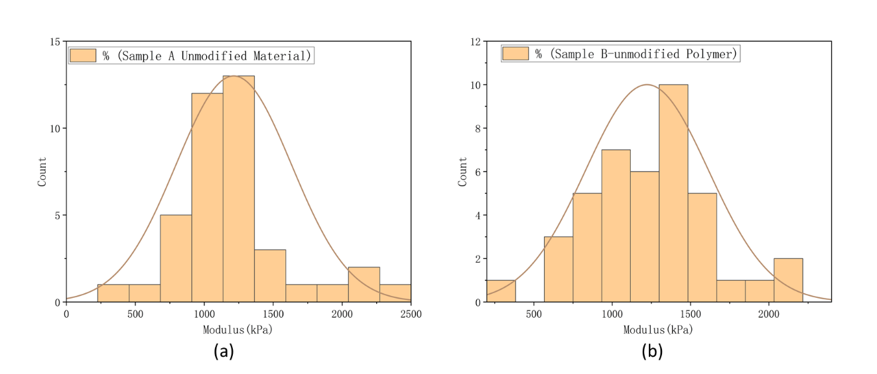
Figure 3. The histogram and normal distribution (plotted according to their mean value and stand error) of (a) unmodified material group and (b) unmodified polymer group
Section 6: Comparability study of the data about modified sample provided by material group and polymer group
Since the size of unmodified material sample and polymer sample are both 4, it is too small to apply the z-test. According to the result of the normality test, As the data provided by both of the modified polymer and material groups satisfy the normal distribution,which makes the t-test available, some detailed results of the t-test has been shown below in table 3:
 | Mean ($X$) | SD (S) | Size (n) | T value
Material | 1985.75 | 85.19145106 | 4 | 4.142120656
Polymer | 2530 | 248.5960579 | 4
Table 4. the result of the t-test between the material group (modified) and polymer group (modified)
The degree of freedom is calculated to be 6. By looking up the table, the critical of the two-tailed test should be 2.447^{[4]}. The t value calculated is 4.1421, which is larger than the critical t value, meaning that the null hypothesis (H₀) is rejected. These two samples are not from the same population, thus they’re incomparable.
Section 7: Comparability study of the data of modified sample and unmodified sample
For the samples from the modified sylgard 184, they are of small size (4 for each sample). The sample from unmodified sylgard 184, all samples are of large sample size (n>30) and can be regarded as normally distributed. The z-test, which can be used to check the difference between new data and a population can be applied.
● Method 1: z-test
The z-test is performed by using the formula (3), regarding the sample of unmodified sylgard 184 as a population and the sample of modified sylgard 184 as a set of new data. Since it is impossible to verify whether the sample of modified sylgard 184 provided by the material group is from the same population as the polymer group, the data of modified sylgard 184 will be tested with the data of unmodified provided by the same group.
$$\begin{aligned}z=\frac{\overline{X}−μ}{S_{\overline{X}}}\#\left(3\right)\end{aligned}$$
The result is shown in table y, compared with the critical value of z (z=1.96), both the result from the material group and polymer group is greatly larger than the critical value, meaning that the null hypothesis (H₀) is rejected and the modified sylgard 184 is not from the same population with unmodified but a new population.
 | SD of modified ($S_{\overline{X}}$) | The mean of modified ($\overline{X}$) | The mean of the unmodified group (μ) | Z-stand score (z)
Material | 248.5960579 | 2530 | 1213.675 | 5.295035694
polymer | 85.19145106 | 1985.75 | 1215.15 | 9.045508563
Table 5. The result of the z-test
● Method 2: Graphic
As shown in figure 4, there’s a great difference in the frequency distribution of the modified one and the unmodified one. Both in the data provided by the material group and the polymer group, the modified slygard 184 sample show a better modulus than unmodified one. From the figure, can it also be said that the modified one is from a different population than unmodified one.
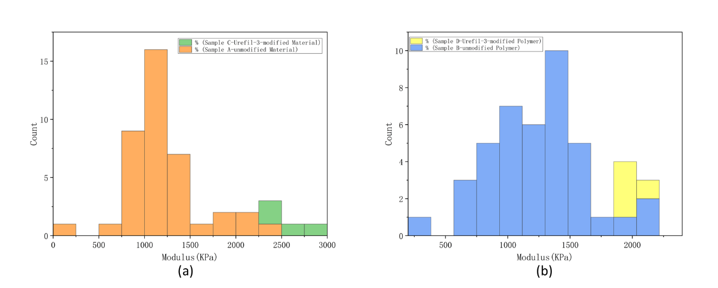
Figure 4. The comparison of histogram between modified and unmodified (a) material (b) polymer
Section 8: Reflection & Conclusion
During this data analysis task, the group encountered several challenges, including identifying and correcting errors in the data, deciding which data points to remove or keep, and selecting appropriate statistical tests to compare the different samples. To overcome these challenges, we utilized a combination of problem-solving skills, critical thinking, and effective group management strategies.

The group start by thoroughly reviewing the data provided and identifying any potential issues or errors, then use appropriate statistical tests to verify our findings and determine the appropriate course of action.

In terms of group management, we divided the tasks among team members to ensure that everyone had a clear role, when we encountered disagreements or differences of opinion, by working collaboratively, communicating effectively, and using evidence-based decision-making strategies, we were able to overcome challenges and achieve our goals.

Reference:
[1] Turney, S. (2022, September 14). Coefficient of determination (R²): Calculation &amp; interpretation. Scribbr. Retrieved March 4, 2023, from https://www.scribbr.com/statistics/coefficient-of-determination/
[2] Bhandari, P. (2023, January 20). How to calculate standard deviation (guide): Calculator &amp; examples. Scribbr. Retrieved March 4, 2023, from https://www.scribbr.com/statistics/standard-deviation/
[3] “Shapiro-Wilk Test for Normality.” Encyclopedia of Measurement and Statistics, 2007, https://doi.org/10.4135/9781412952644.n404.
[4] 1.3.6.7.2. Critical Values of the Student's-T Distribution, from https://www.itl.nist.gov/div898/handbook/eda/section3/eda3672.htm.

